ECEN 4/5632 Theory and Application of Digital Filters Fall 2026
10-9-26 P. Mathys

Problem Set 7: Solution
1. FIR filter classification & frequency response derivation
Given four causal discrete-time FIR systems with impulse responses defined for $0≤n≤M$:
1. $h_{1}[n] = [1,3,5,3,1]$
2. $h_{2}[n] = [2,-1,4,4,-1,2]$
3. $h_{3}[n] = [1,2,0,-2,-1]$
4. $h_{4}[n] = [-1,3,-3,1]$
(a) Classify each system into its corresponding FIR Type (I, II, III, or IV). Specify the filter order $M$ and sequence length $N$ for each.
(b) For $h_{2}[n]$, derive the compact closed-form expression for its frequency response $H_{2}(e^{jω})$. Express $H_{2}(e^{jω})$ in the form $A\left(ω\right)e^{-jM/2}$ where $A(ω)$ is a real-valued trigonometric sum.
(c) For $h_{3}[n]$, derive $H_{3}(e^{jω})$ and show that it exhibits a constant ${90}^{o}$ ($π/2$ rad) phase shift relative to the linear phase delay term $e^{-jM/2}$.
2. Zero Constellation Symmetry & System Synthesis
(a) Prove that if $z_{0}=re^{jθ}$ (with $r≠1$ and $θ≠0,π$) is a zero of a causal, real-coefficient linear-phase FIR filter $H(z)$, then $z_{0}, z_{0}^{*}, 1/{z_{0}}$, and $1/{z_{0}^{*}}$ must also be zeros of $H(z)$ with equal multiplicity.
(b) A Type I FIR filter of order $M=4$ ($N=5$) with real impulse response $h[n]$ has a complex zero at:
$$z_{1}=\frac{1}{2}e^{jπ/3}$$
i. List all four zeros of $H(z)$ in both polar and Cartesian forms.
ii. Derive the normalized system transfer function $H(z)$ given that $H(e^{j0})=1$.
iii. Determine the explicit impulse response sequence $h[n]$ for $n=0,1,2,3,4$.

3. System interconnections and composite types
Consider two causal linear-phase FIR filters: $H_{A}(z)$ of Type II with order $M_{A}$, and $H_{B}(z)$ of Type IV with order $M_{B}$.
(a) Determine the FIR Type (I, II, III, or IV) of the cascaded system $H_{C}(z)=H_{A}\left(z\right){∙H}_{B}(z)$. Express the overall order $M_{C}$ in terms of $M_{A}$ and $M_{B}$, and justify the symmetry of $h_{C}[n]$.
(b) Assume $M_{A}=M_{B}=M$. Determine whether the parallel interconnection $H_{D}(z)=H_{A}(z)+H_{B}(z)$ maintains strict generalized linear phase. Support your answer mathematically by evaluating the phase of $H_{D}(e^{jω})$.
(c) Can a parallel combination of a Type I filter $H_{1}(z)$ and a Type III filter $H_{3}(z)$ with identical delay $τ=M/2$ yield a linear phase system? Explain.
4. Filter flowgraph (ECEN 5632 Problem)
Consider the filter flowgraph shown in the figure below:
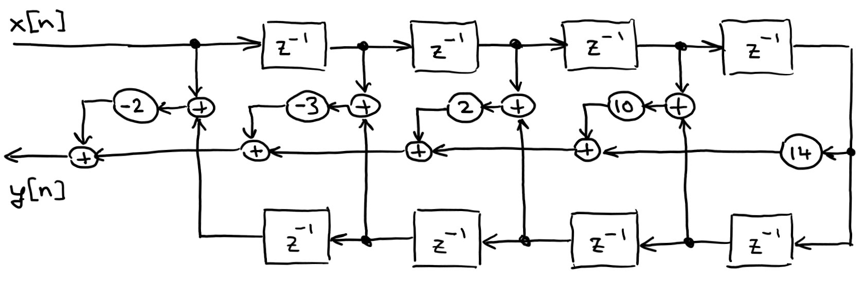
The $z^{-1}$ cells are delay cells and the bubbles with numbers in them are multipliers with the numbers giving the multiplication factors. The bubbles with + signs are adders, the branch labeled $x[n]$ is the input of the filter and the branch labeled $y\left[n\right]$ is the output of the filter.
(a) Determine the unit impulse response $h[n]$ of the filter shown above and display the result in the form of a labeled stem plot. What type of a filter is it?
(b) What would be the main advantage of implementing a filter in this way? Are there any disadvantages?
(c) Could you implement a Type III and/or Type IV FIR filter in this way? If yes, what would you have to change, if no, why not?

